If you want to use the LPR camera to control the door, please follow the steps below:
- Please config the Alarm Output setting.
Note: Valid signal “Close/Open” means the camera will send a Close/Open signal to the door/gate
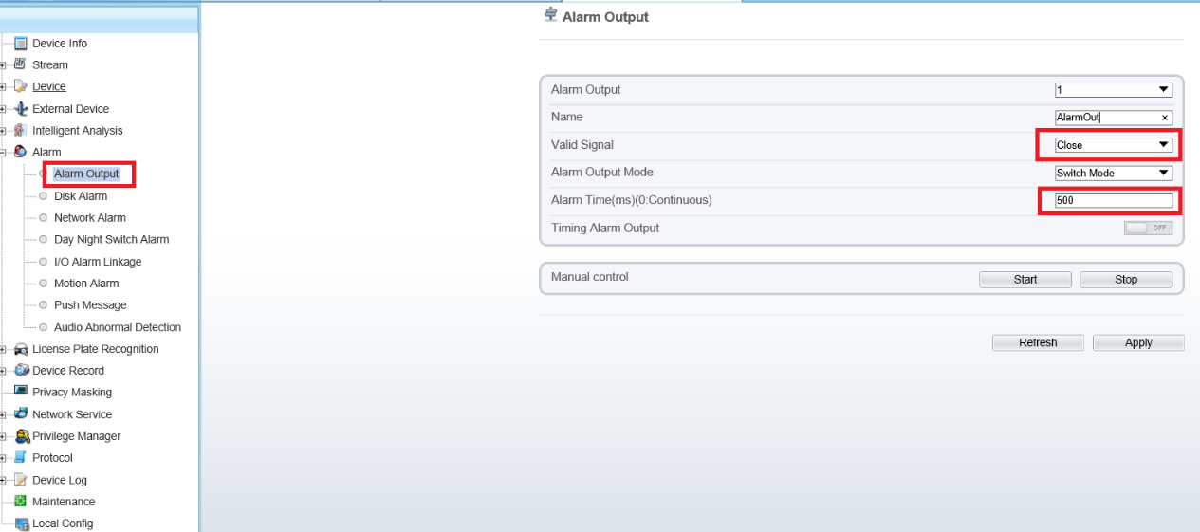

Parameter | Description | Setting
Alarm Output | ID of the alarm output channel.  NOTE  The number of alarm output channels depends on the device model. | [Setting method]  Select a value from the drop-down list box.  [Default value]  1
Name | Alarm output channel name. | [Value range]  0 to 32 bytes
Valid Signal | The options are as follows:  - Close: An alarm is generated when an external alarm signal is received.  - Open: An alarm is generated when no external alarm signal is received. | [Setting method]  Select a value from the drop-down list box.  [Default value]  Close
Alarm Output Mode | When the device receives I/O alarm signals, the device sends the alarm information to an external alarm device in the mode specified by this parameter. The options include the switch mode and pulse mode.  NOTE  - If the switch mode is used, the alarm frequency of the device must be the same as that of the external alarm device.  - If the pulse mode is used, the alarm frequency of the external alarm device can be configured. | [Setting method]  Select a value from the drop-down list box.  [Default value]  Switch Mode
Alarm Time(ms) (0: Continuous) | Alarm output duration. The value 0 indicates that the alarm remains valid. | [Setting method]  Enter a value manually.  [Default value]  0  [Value range]  0 to 86400 seconds
Timing Alarm Output | The camera will output alarm continuously according to the Timing Alarm schedule | You can set the schedule
Manual Control | Control the alarm output. (You can use this option to test if the alarm output works) | N/A
2. Please go to “License Plate Recognition” to enable license plate recognition, then draw the detection area and set the schedule. (it’s enabled by default, so you can leave it by default)
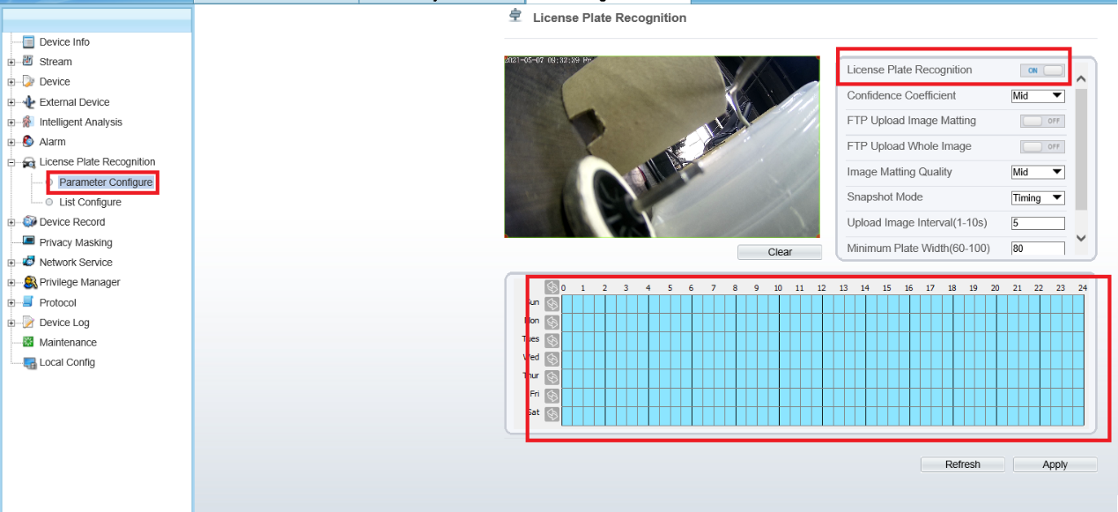
3. Please go to “List Configure” to add the plates (blacklist/whitelist).
Then please click on “Advanced”, and select “White List” (or other options) as the door open condition, then enable “Relay On” option, then Apply.
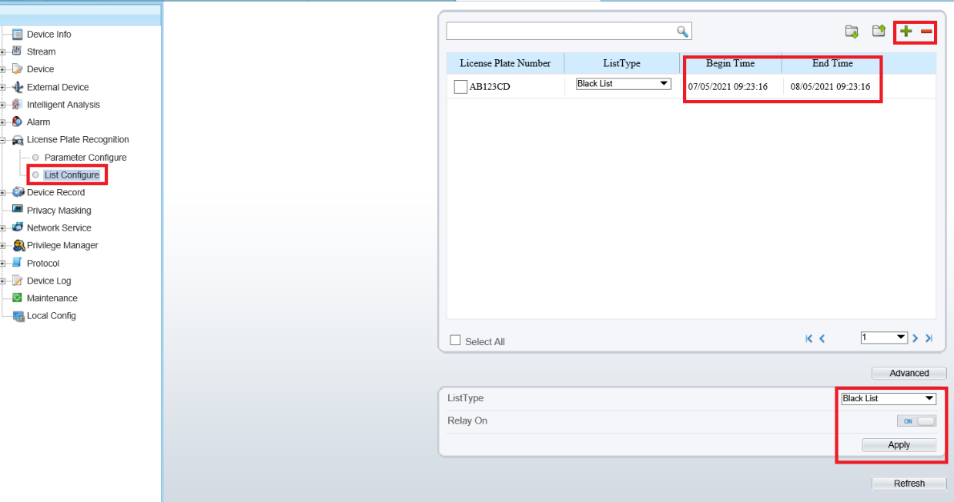
4. Please connect the camera’s alarm out cables to your door’s relay.
You can find the correct cables according to the label.
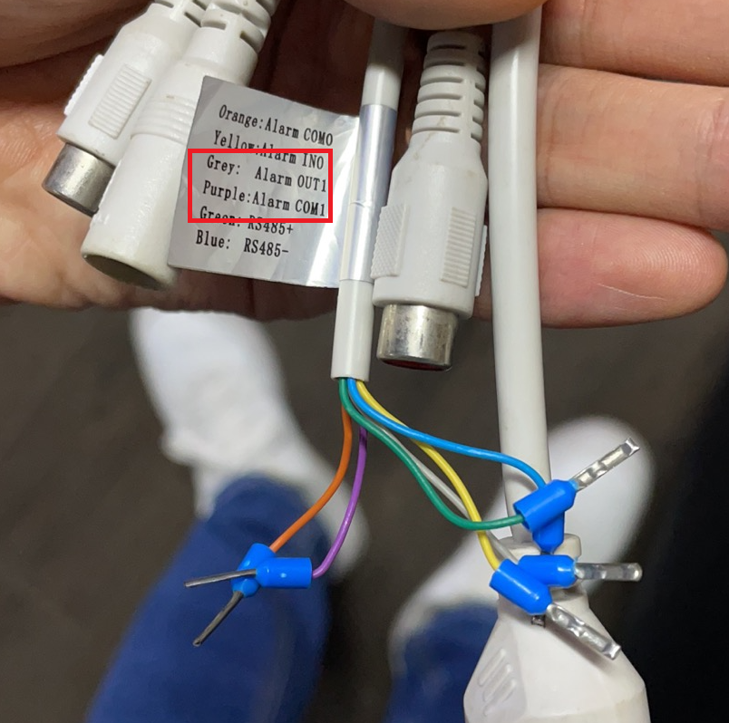
5. When the camera recognizes the “White List” (according to your setting on step3), the camera will send a Close/Open signal to your door’s relay to Close/Open the door.
